GGN - Geopark Annual Report 2018

1. GEOPARK IDENTITY
Geopark name, country, regional Network:
Fangshan UNESCO Global Geopark (People’s Republic of China, APGN)
Year of inscription / Year of the last revalidation: 2006/2018
Representative Photo (from the most important event this year)
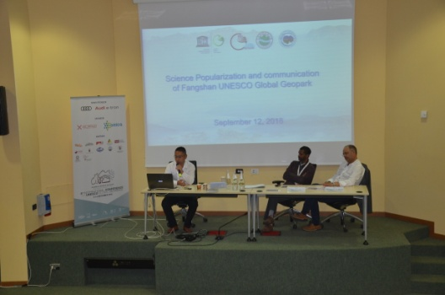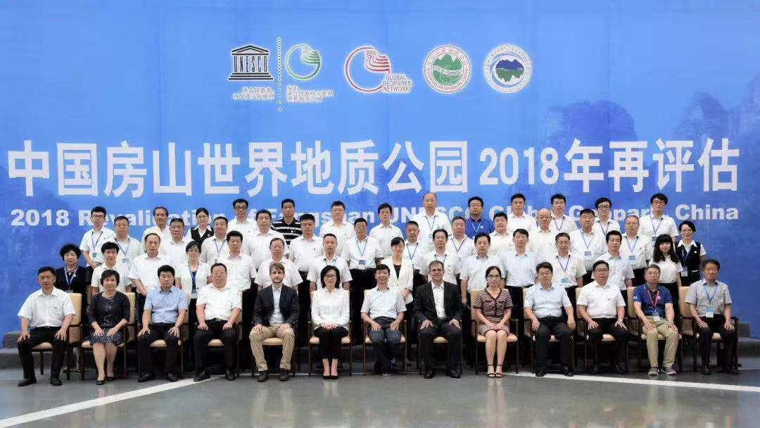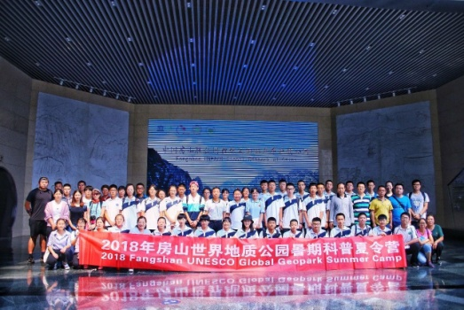
Attended the 8th UNESCO Global Geopark conference Fangshan UGGp 2018 revalidation Organized geo-science summer camp

2. GEOPARK FIGURES
Number of Geopark staffs: 1150 staffs including 8 geoscientist(s)
Number of Visitors: 8.4million
Number of Geopark events: Organized the Geo-science summer camp
Number school classes realize Geopark educational programmes: 650
Number of Geopark press release: 195

3. GEOPARK ACTIVITIES
Major achivements in 2018
Contribution towards GGN - Networking and Participation
Participated the 8th UNESCO Global Geopark conference, Annual meeting of CGN, organized the geo-science summer camp, 3 rd International Course on Geopark Management and Development, and held the theme activities of GGN.

Management and Financial status
Fangshan UGGp has a unified management body named "Fangshan UGGP Administrative Commitee, whose routine work is done by ―". The eight areas have their own management body, taking charge of geoconservation, development, scientific education, promotion and management. Since joining the GGN, Fangshan UGGp has maintained a sound financial position with the balanced budget and a certain surplus. The Geopark's revenue can meet the investment to achieve the purpose of geoconservation, ecological resoration and conservation, infrastructure maintenance, geoscientific research, cooperation and promotion.

Geoconservation
New achievements have been made in the protection of geological heritages. An expert team was hired to work out a plan for adjusting the boundary area of the geopark, and the geographical boundary area of the park was defined. The investigation of geological heritages in Zhoukoudian, the study of the influence of geological function and evolution on human culture and the investigation of Shidu biodiversity were carried out. The site map of geological heritages was compiled, 27 new scientific achievements were added, 25 rock specimens were collected, and 890 meters of geological heritages protection fence was built in Shangfangshan.

Sustainable tourism (Geotourism)
Besides geoconservation, scientific research and education, Fangshan UGGp has paid
more attention to geotourism develop, which has created jobs for local residents and
increased their income. In 2018, the Geopark has received 8.4million visitors, with a total revenue of 2.7billion yuan.

New Education programmes on geoconservation, sustainable development and disaster risk reduction
We will carry out a series of activities such as "Four Entries" of popular science education and mobile museums, and carry out popular science propaganda in 18 units such as Changgou Middle School, Geological University College of China, and community. Establish cooperative relationship with Haotian School, Tuoli Middle School, Changgou Middle School and Guandao Kindergarten, design 5 research travel routes and carry out 7 research travel activities. Propaganda videos and microvideos of popular science bases were produced. Activities such as "World Earth Day" theme education and social classes for primary and secondary school students in Beijing were carried out in the Geopark Museum. More than 32,000 students from 110 schools in the city were received, and more than 100,000 books of popular science books and folders of publicity were distributed. In 2018, the Science Popularization Series of Fangshan Global Geopark in China was awarded excellent science books by the Ministry of Natural Resources and recommended to the society for reading.

The renovation project of tourism service facilities in the northern Geopark has been completed. In Baicaoban, Baihuashan, Bairui Valley and Shenglianshan, 3264 square meters of scenic platform, 384 square meters of leisure corridor frame, 50 ecological toilets, 122 garbage cans, 205 rest seats and 70 courtyard lamps have been built. A new mining relics exhibition center of 6,000 square meters will be built. The general surgical activity area of the geopark museum room will be rebuilt to 2,000 square meters. 77 large-scale billboards and traffic signs will be set up. 303 landmarks and science popularization instructions will be renewed in Zhoukoudian and Yunju Temple. 76 new science popularization information frames will be built. The overall service level of the park will be satisfactory.
we have made prevention, treatment and emergency plans of meteorological hazards, geological hazards and forest insect damage; also collaborated with the meteorological department and radio and television departments to establish a geohazard forecast and warning information system.
Strategic Partnership
Actively participate in the 8th Global Geopark Conference, the Fourth International Training Course of the Global Geopark, the Annual Meeting of the Global Geopark in China and the Training Course of the Popular Science Base of Land and Resources, organize managers to exchange visits and exchanges with Alashan and Yandang Mountain Global Geoparks, and sign friendly museums with the National Museum of Natural History of France. In cooperation with Danxia Mountain, Tianzhu Mountain Global Geopark and Liangxiang Affiliated Secondary School of Beijing Normal University, carry out summer popular science camp activities, learn and exchange experience in the construction and management of geoparks, and promote common progress. Compilation of Geopark picture albums and tourist souvenir atlas, research and development of Geopark souvenirs such as folding fans, logo boxes

Promotional activities
Held Fangshan Tourism Culture Festival and International Long Distance Walk festival, Laozi Cultural Festival, the Mountain Festival in Yesanpo Bailixia. Compilation of Geopark picture albums and tourist souvenir atlas, research and development of Geopark souvenirs such as folding fans, logo boxes, complete the revision of Chinese and English websites, publish 178 kinds of information, and publish 15 publicity articles on Xinhua and Guangming websites, further expanding the popularity and influence of parks. .

4. Contacts:
Manager: Yang Jianpo 565366789@qq.com
Geologist: Jing Zhixing

